**PROCESS INSTRUMENTATION**

**Name: Vivek Chandrashekhar Rugale**

**GR No.: 11810369**

**Div.: TY-C**

**Roll No.: 24 (Batch B1)**

**LAB 1:**

**Aim - Characterize the given I to P convertor On Virtual Lab**

1. Introduction –

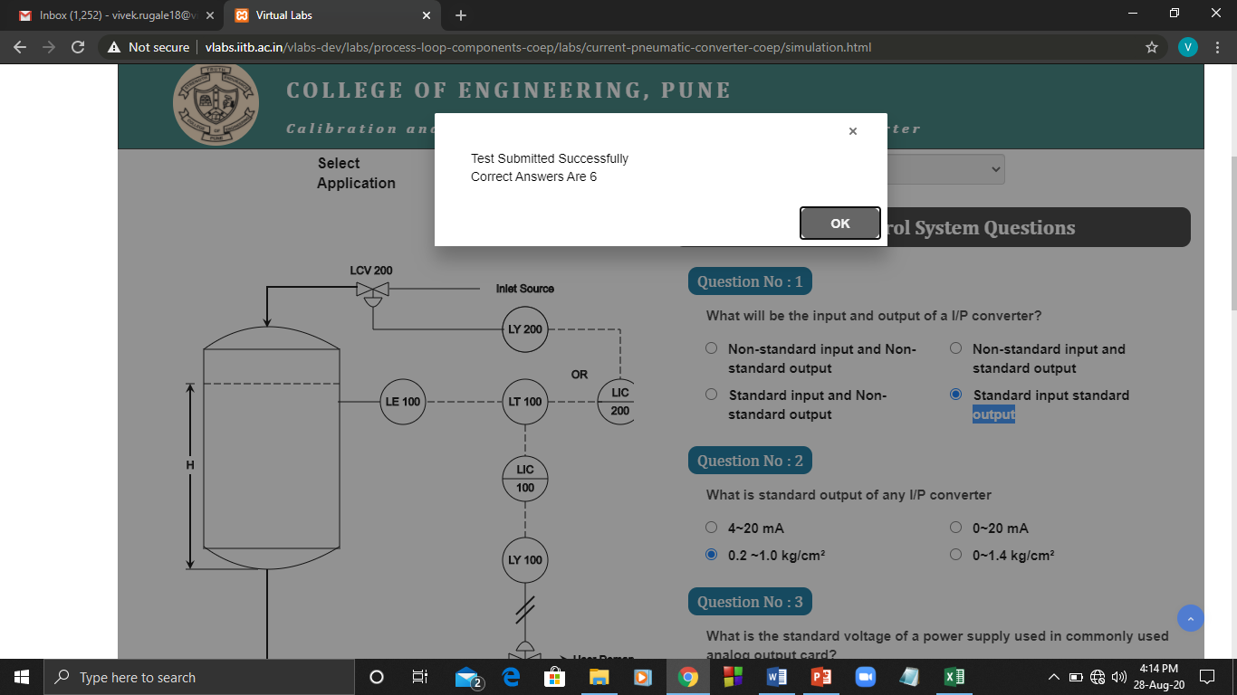

1. Configuration –

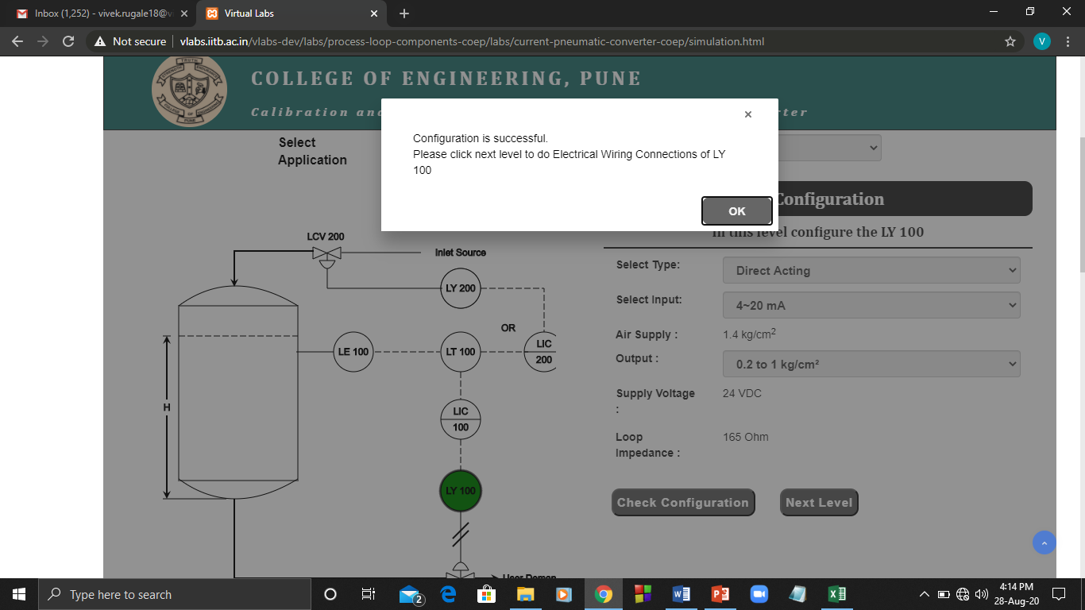

1. Connection –

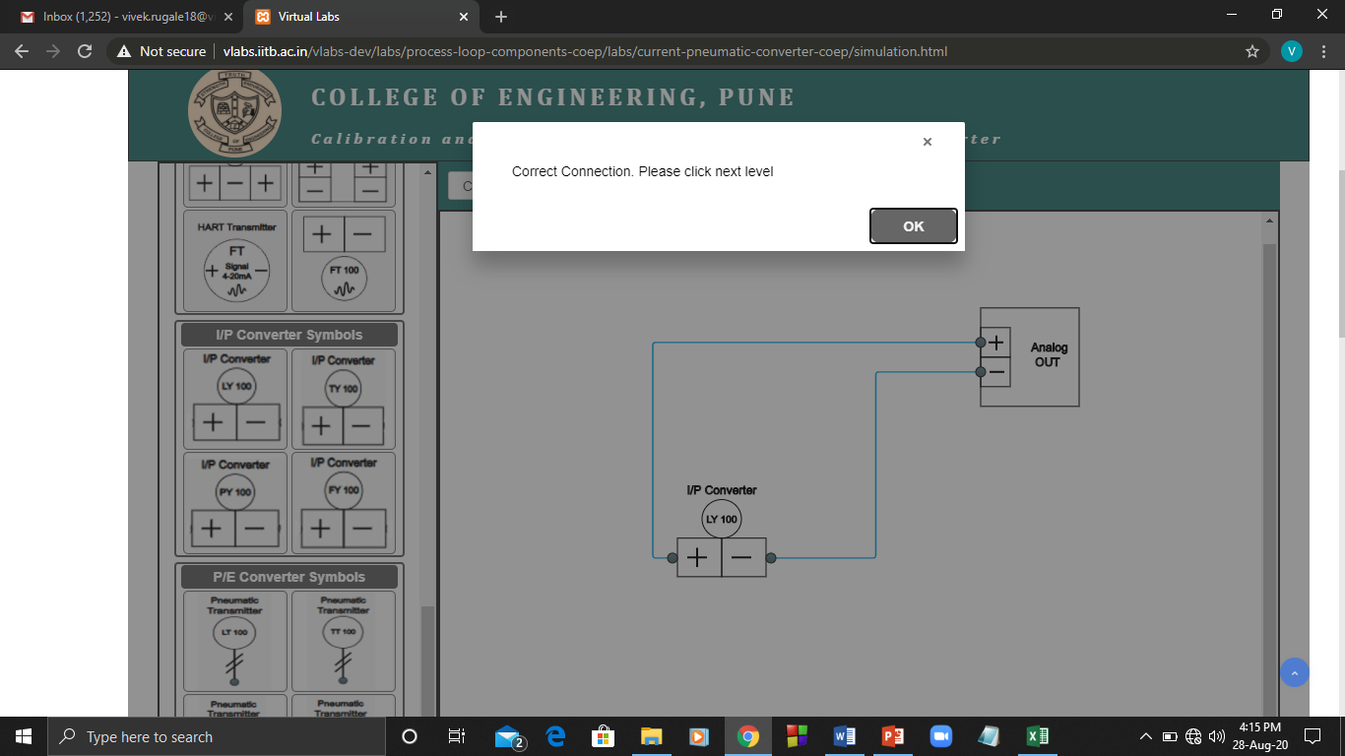

1. Characterization –

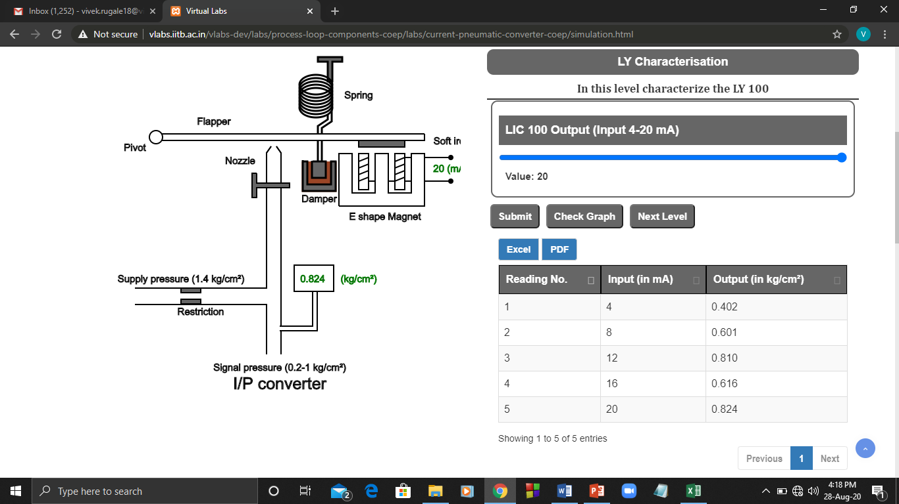

1. Calibration –

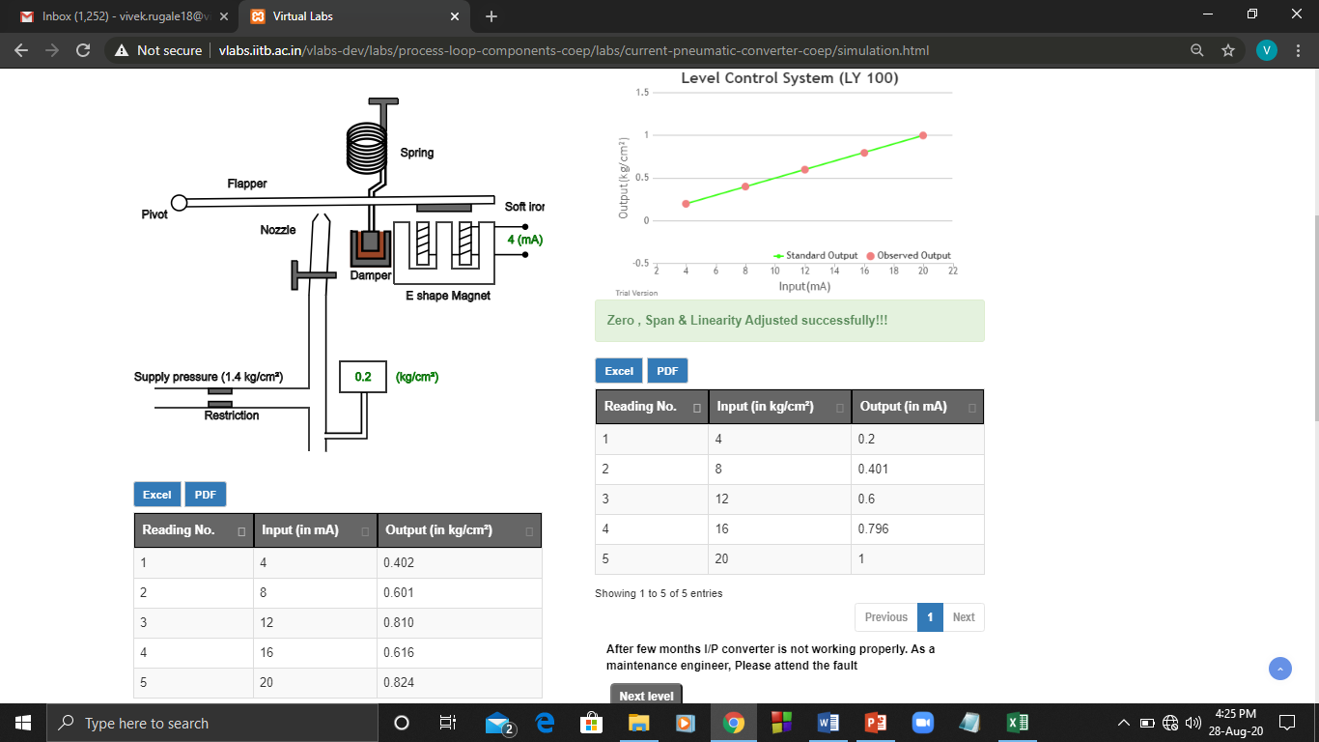

1. Fault Detection -

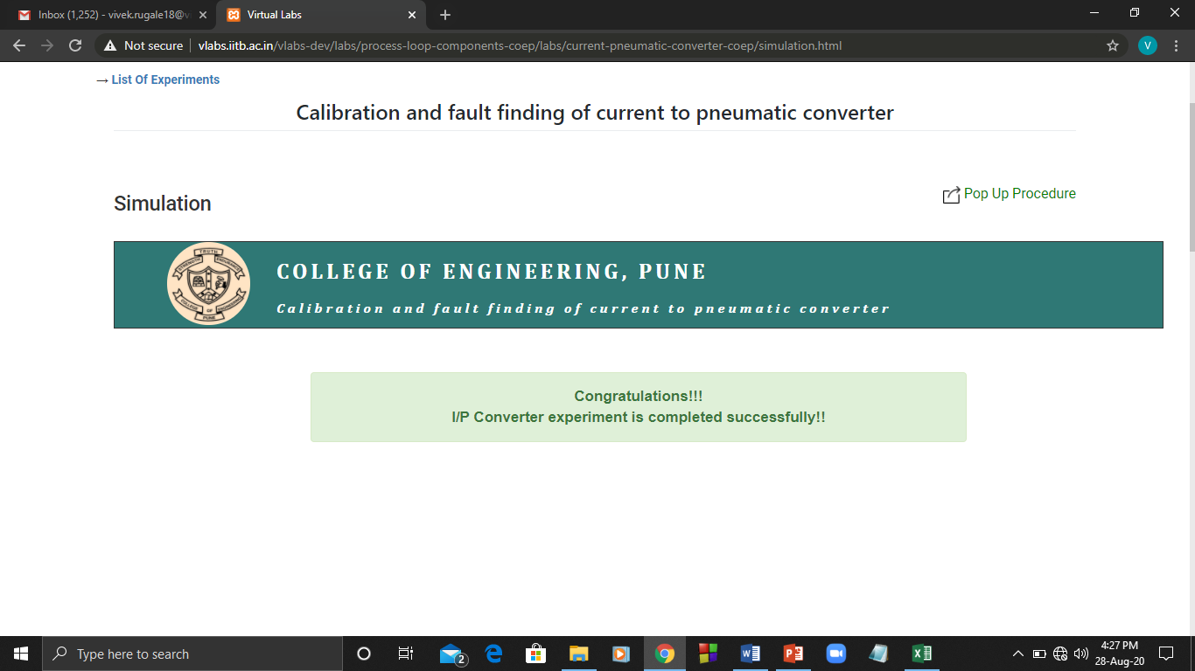

**Conclusion:** Experiment was performed on virtual labs platform. Output pressure readings taken through simulation. Calibrated the I to P converter and removed errors to get linearity.